4-Department Azure Hierarchy Architecture

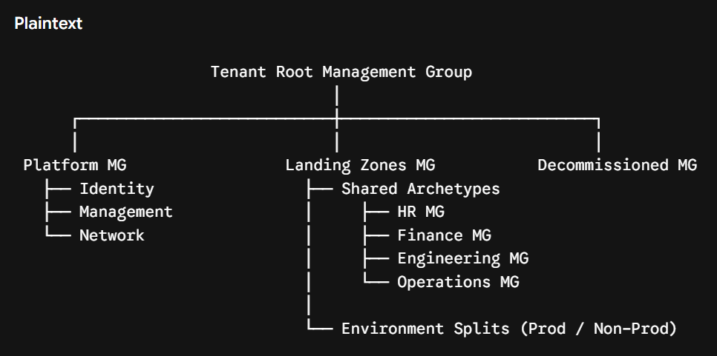

Deploy Management Group Hierarchy

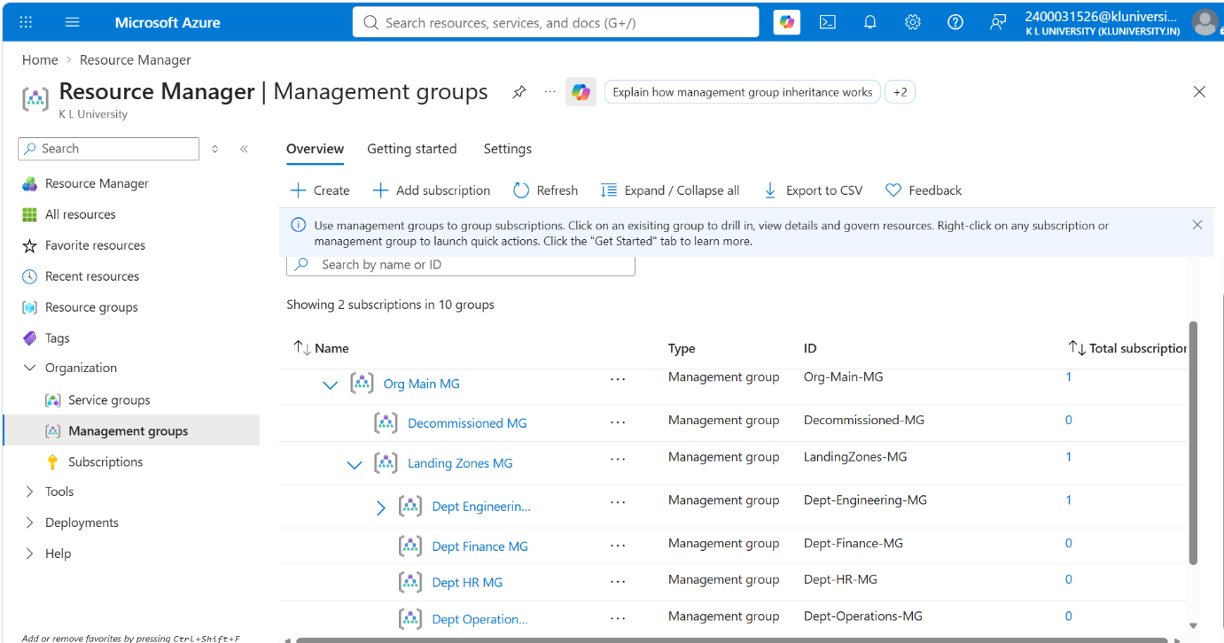
Phase 1 Verification Checklist

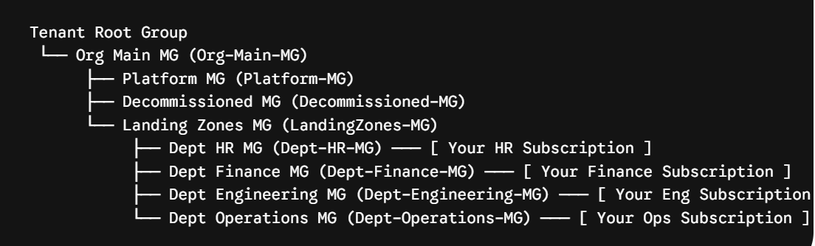

Configure Policy Inheritance & Roles

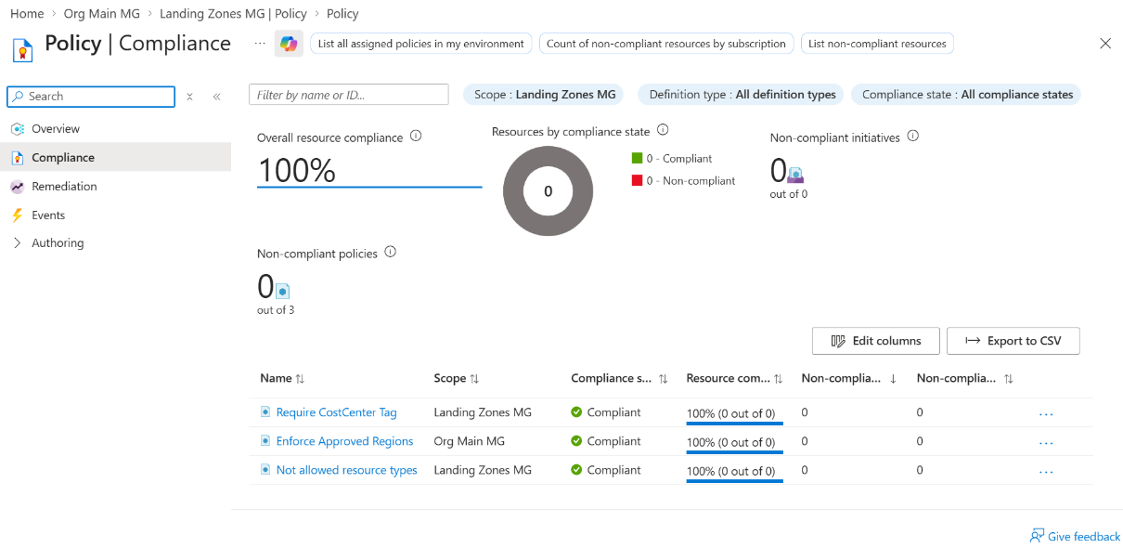
Assign Baseline Region Lock at Top Level (Org-Main-MG)
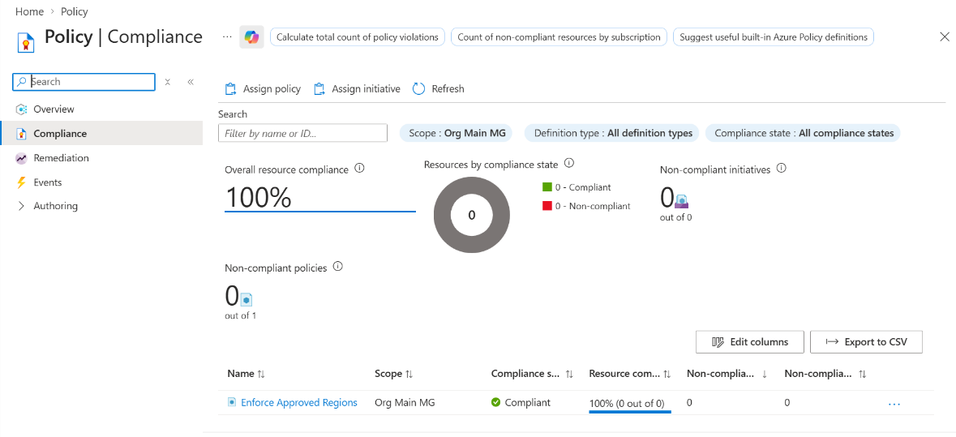

Assign Tagging Compliance Policy at Mid Tier (LandingZones-MG)

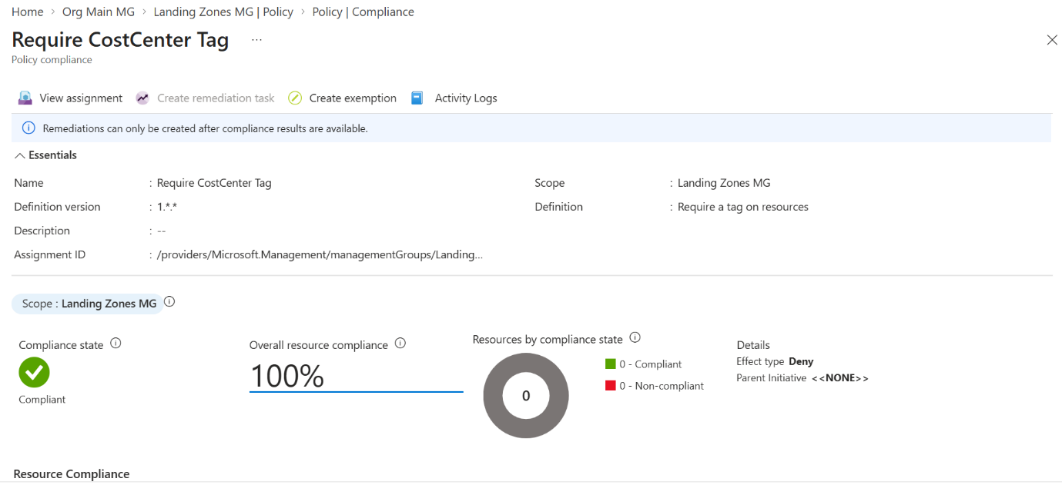

Assign VM SKU Restriction at Leaf Tier (Dept-Engineering-MG)

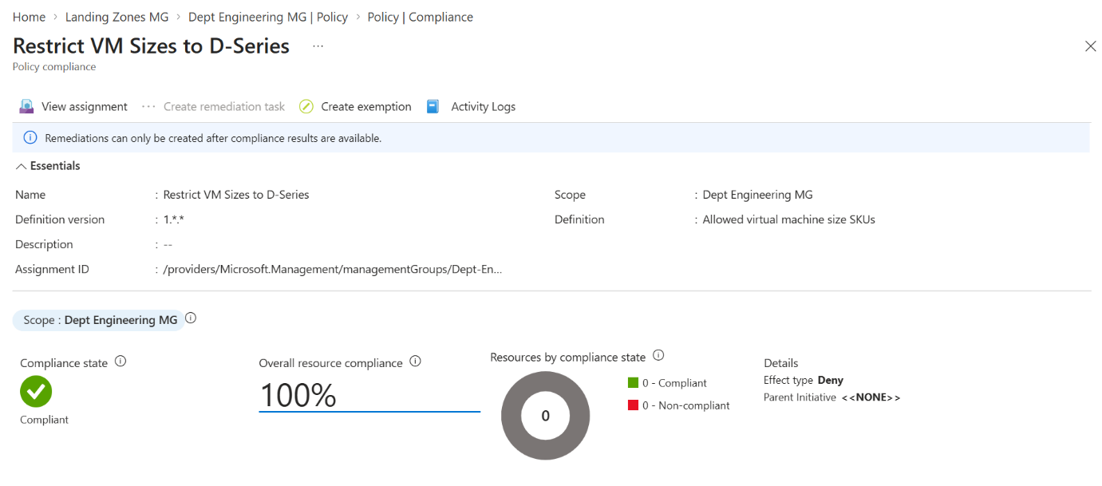

Configure Role-Based Access Control (RBAC Roles)

